**SUMMARY**

* After setting up the Oracle cloud environment, created a database using the autonomous database option with the display name “MGS657”
* For data modeling I have used the SQL worksheets tool from the database actions option to create tables.
* I have created Dimensions tables like employees, customers, products, orders, stores, promotion, shipping, supplier tables, and sales fact table.
* Created all the required attributes/fields for every table using edit options without writing SQL commands.
* Assigned unique identifiers as primary keys for all the dimension and fact tables.
* Established one-to-many relations link between dimension-to-dimension tables and from all dimensions tables to fact table using the primary key of a dimension table making it a foreign key of another dimension/fact table. These relations help to query and extract required data to perform requested operations.
* All the tables are indexed such that to form a star schema pattern.
* Using the data modeler tool from the database actions option, created a database diagram in star schema involving all the dimensions and a fact table that shows the one-to-many relations between all the dimension tables, and between all dimensions and the fact table.
* Fact table contains quantitative data for analysis and is often in denormalized form, foreign keys column allows relation with dimension tables, and the measures columns contain the calculated quantitative data.
* Nulls should be avoided in the fact table's foreign keys as they would cause referential integrity violation.
* In Star schema dimension tables are denormalized, it will only join the fact table with the dimension tables, leading to easier, faster SQL queries.

**Dimensional Model:**

**Foreign Key Relations:**

Employees Table:

Order Table:

Product Table:

Promotion Table:

Sales Table:

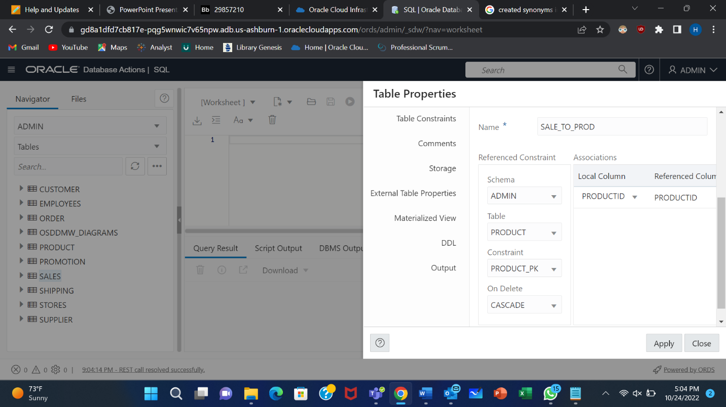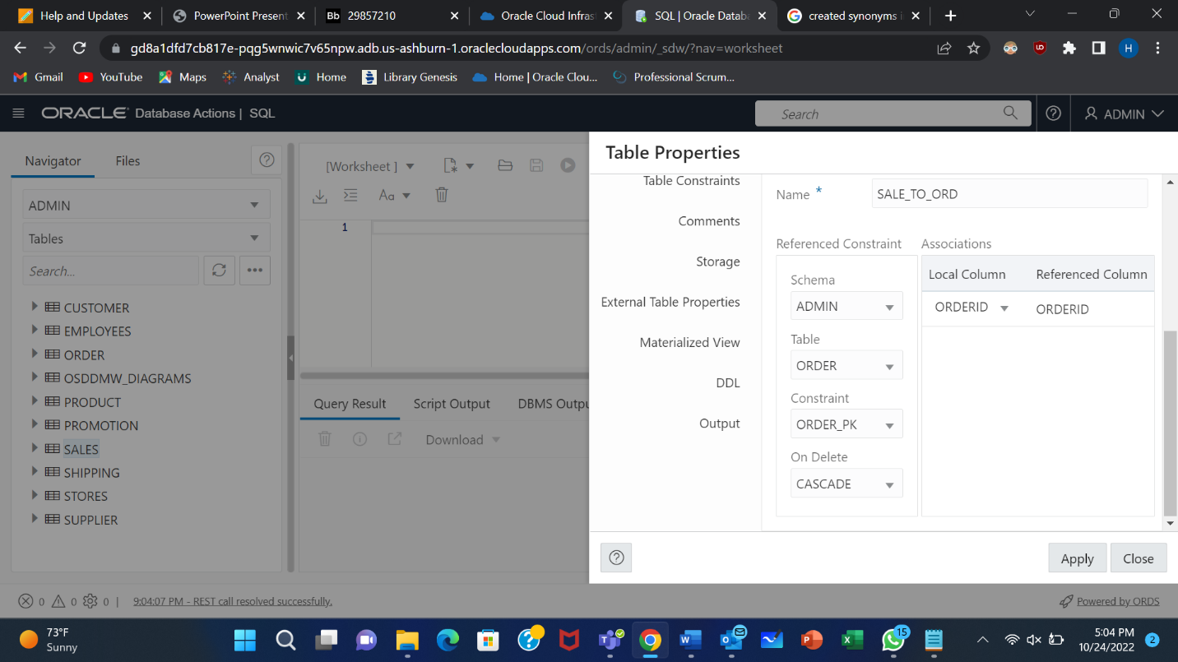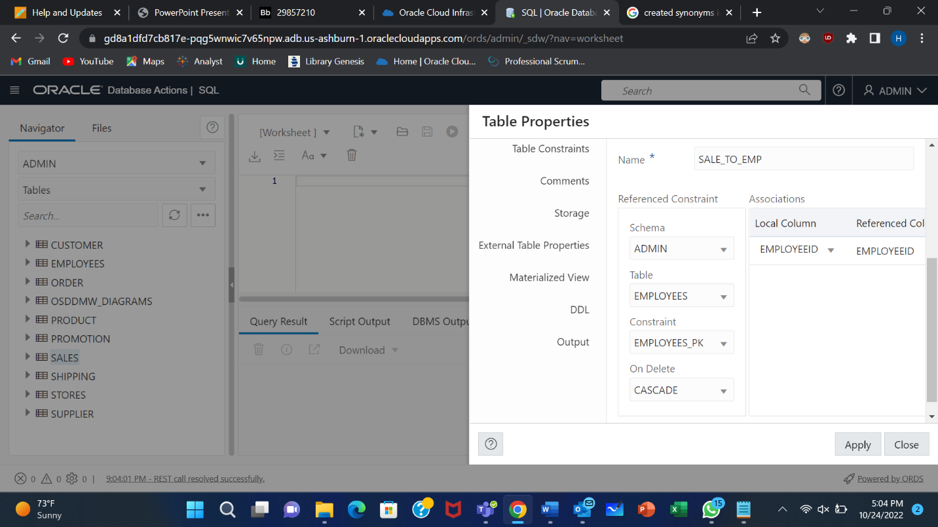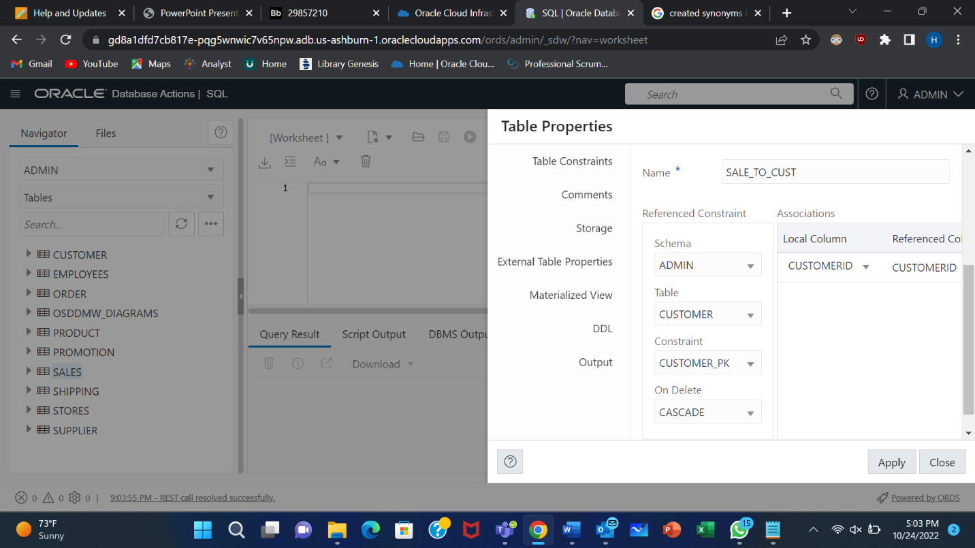

Shipping Table:

Supplier Table:

